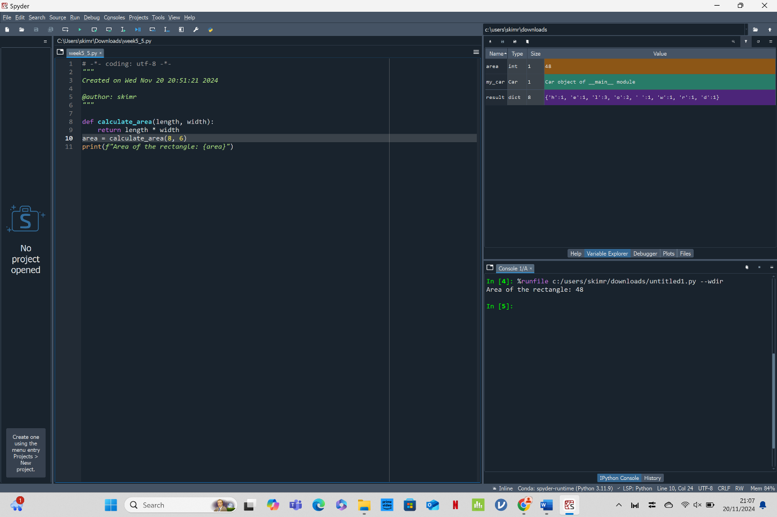

* The function calculate_area calculates the area of a rectangle given its length and width.
* The function is called with the values 8 and 6, and the area is calculated as 48.
* The result is printed as "Area of the rectangle: 48".

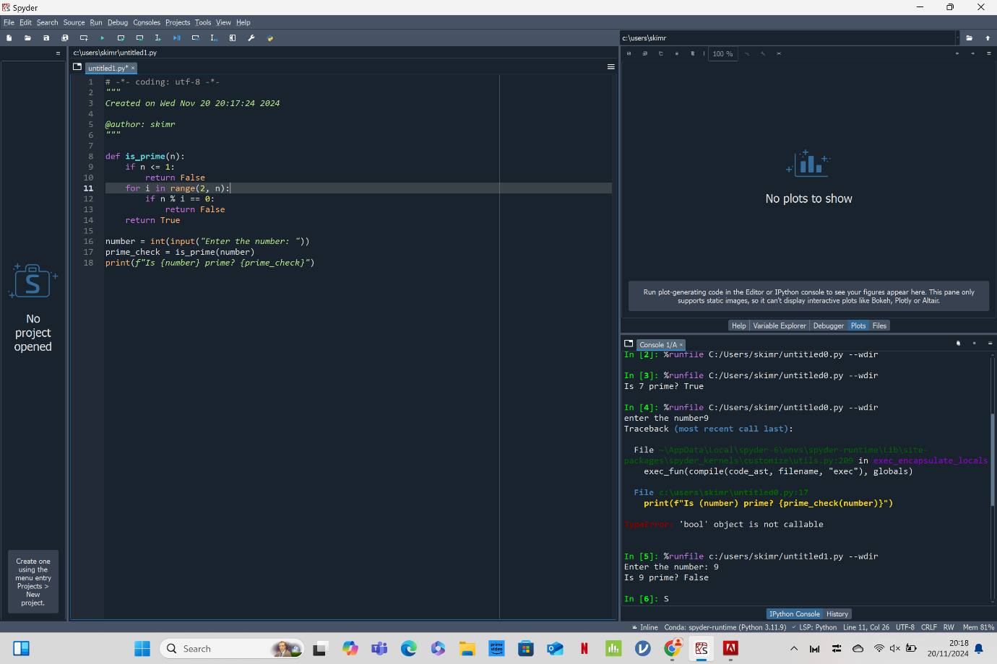

* The function is_prime(n) checks if a number n is prime by testing divisibility with all numbers from 2 to n-1. If no divisors are found, it returns True (indicating n is prime); otherwise, it returns False.
* The user inputs a number, the primality of the number is checked, and the result is printed.

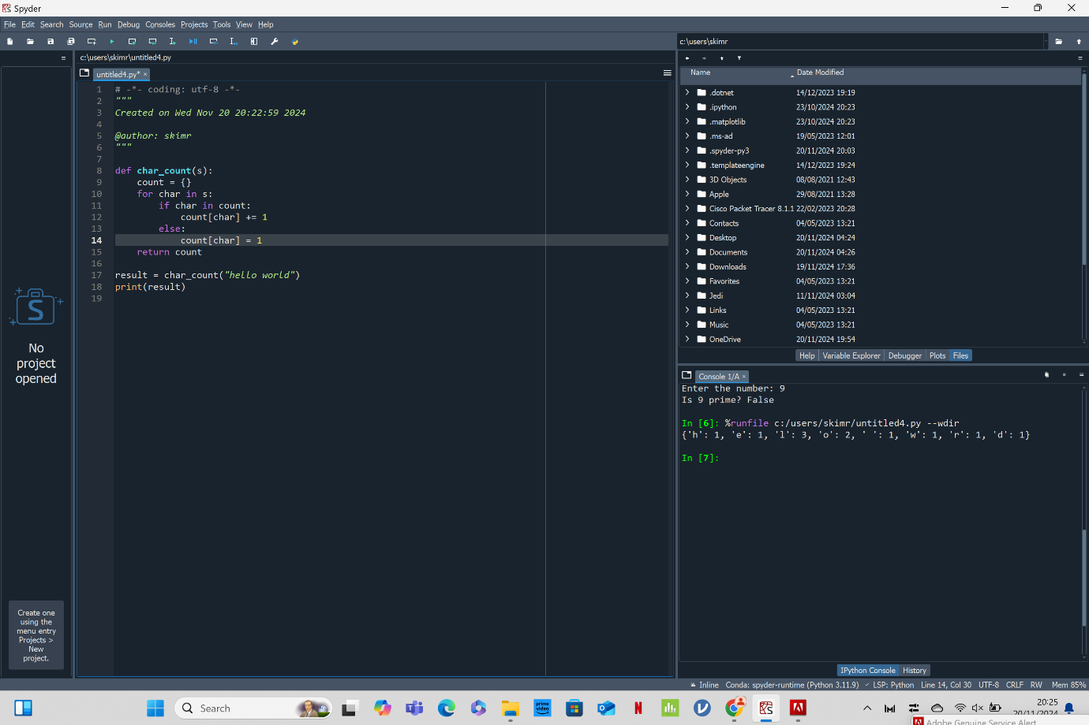

* The char_count function counts the frequency of each character in a given string.
* It uses a dictionary to store the characters as keys and their corresponding counts as values.
* The function efficiently processes the string in a single pass, updating the dictionary with each character's count, and returns the final dictionary with the character frequencies.

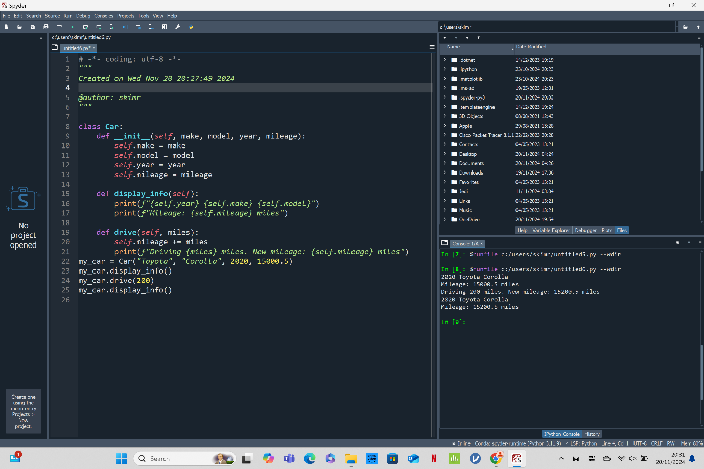

* The Car class models a car with attributes like make, model, year, and mileage.
* __init__: Initializes the car object with its make, model, year, and mileage.
* Displays the car's information (make, model, year, and mileage).
* Simulates driving the car by increasing its mileage and printing the new mileage.
* The object my_car is created with specific values for make, model, year, and mileage.
* The display_info method is called to show the car's details.
* The drive method is called to simulate driving the car for 200 miles and updating the mileage.
* display_info is called again to show the updated mileage.

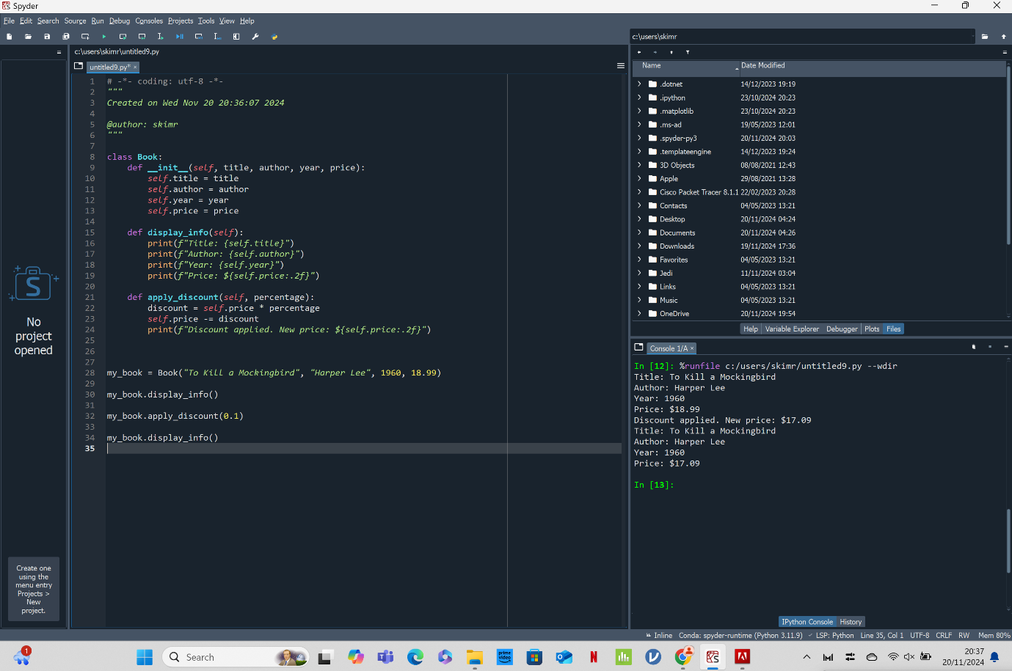

* A Book class is defined with attributes (title, author, year, price) and methods (display_info, apply_discount).
* A Book object is created with specific details.
* The book information is displayed.
* A discount is applied to the price of the book.
* The updated book information, including the new price after the discount, is displayed.